ATD Bay Colonies
Monthly Board Meeting Minutes
August 16, 2023 | 1:00PM - 4:00PM

Attendees: Brian, Catherine, Peter, Miko, Michael, Heather, Wendy, Elizabeth, Rod, Lisa, Dayne
Call to order: 1:05PM
Approval of minutes: Wendy and Heather

- Annual Report
- Include in the “welcome to the season” email
  - Letter from Past President – page 2 (Wendy)
  - Financial Report – pages 5-6 (Peter)
  - 2023-2024 Goals – page 8 (Group/Elizabeth)
  - 2023-2024 Programming – page 10 (Elizabeth)
  - Membership & Operations – pages 11-12 (Lisa/Rod/Catherine)
  - Communication & Marketing – page 13 (Elizabeth/Heather)
  - Chapter Accomplishments and Chapter Activities – pages 14-15 (Group/Elizabeth)
    - Accomplishments: Increase in membership, Bite-Sized Learning series
    - Activities: Kick-off, event at Zoo, 1st in-person event certification

- Communication plan for August/September
  - Kick-off email with Annual Report and announce 1st event (launch now)
    - Introduce name change & anniversary
  - Graphic send out separately (few days later)
  - Promote September Event on LinkedIn and site (8/17)
  - Early Sept. send event email - Catherine

- Finances
  - Wild Apricot - should move to the full year subscription
  - Lisa & Peter to discuss further
  - Budget - Peter will complete it once membership, event structure, etc. has been finalized
  - Online banking & mobile app - still sorting the account out with bank
  - Checks need to be made out to ASTD until name change! Include mailbox #
  - Audit with Central Mass coming up - will be entered into CARE

- 2023 - 2024 Programming

September Event | Two Chapter Two-Step
9/20 - Six Strings (Patriot Place, Foxboro MA) @ 5:30pm
- POC: Lisa Robbins
- Song/Genre: Country
    - Networking with Boston Chapter
    - 5:30-6:00 - arrival (food starts at 5:30pm)
    - 6:00 - event starts (organized networking)
    - 7:30 - ends
      - Private room booked & additional space
      - Line dancing ends at 10pm
      - Menu: Most likely passed apps
      - $25 - members
      - $40 - non-members
    - Open items:
      - Adjust graphic for this event to start at 5:30pm
      - Bring banners & swag

October Event | New England Area Conference
10/20 (Great Wolf Lodge, Fitchburg MA)
- POC:
  - Event: NEAC (promote this event for members)
October BSL Event | 10/27 & 12-1pm
- POC: Catherine Thenault
- Topic: TBD
November Event | Harnessing the Power of ChatGPT for Talent Development
11/8 @ 12-1:30pm (virtual) with Stan Skrabut
- POC: Brian Lopes
- Open items:
  - Dry Run planning meeting
  - Market with Central Mass
  - Catherine will set up the Zoom

December Event | Charity & Cheer
12/7 @ need time, Angelo’s in Cumberland
- POC: Michael Merline
  - Event: Charity & Cheer & Crossroads
    - Karaoke, musical bingo,
  - Open items:
    - Figure out space (private vs public); 20-25 people
    - Thursday’s - musical bingo?
December BSL Event | 12/8 & 12-1pm
- POC: Lisa Robbins
- Topic: Self Care/Wellness - part of the ATD capability model

January Event | Shift Happens
1/17 @ 12-1:30pm (Virtual with Brandy Ford)
- POC: Wendy Picard
- Open items:
  - Set up dry run

February Event | Safe Spaces for Learning
2/15 @ 8-9:30am (Virtual with Kelli Frey)
- POC: Wendy Picard
- Coordinating with Maine Chapter

March BSL Event
3/1 @ 12-1pm
- POC: Wendy Picard
- Topic: Psychological Safety

March Event | Learning in the Moment of Need
3/19 @ 12-1:30pm (Virtual)
- POC: Peter Ward

April Event | Accessibility A-Z
4/23 @ 8-9:30 (In-person; FM Global)
- POC: Wendy Picard
- Open items:
  - Figure out space at FM Global

April BSL Event
4/12 @ 12-1pm
- POC: Miko Nino
- Topic: TBD

May BSL Event
5/31 @ 12-1pm
POC: Rodrigo Tempestini

June Event | One! More! Song!
First week in June (6/6) & time

- Goals
  - 1 more corporate partner (companies to represent members); Diversify membership by adding 3 more companies
    - AAA, Blue Cross Blue Shields, IGT, Fidelity, Leadership RI, Bryant University, UNIFY, CVS, RI State Offices, RI College, CCRI,
    - Tech/IT departments
    - Reach out via LinkedIn; Rod/Jay/Brian - outreach strategy
    - Lisa Robbins/Rodrigo Tempestini to send out active/non-active member list and their company names
- Maintain CARE Plus
- Sustain Community Outreach
- Employee learning week in December (first week 4th - 8th)
    - BSL
    - Charity & Cheer
- Consistent monthly newsletter
- Increase networking opportunities
- Partner with other chapters

- Member Pricing
Lisa emailed Chapter Comparison of member pricing
    - Some Chapters charge higher and have free events (with lower attendance rates)
    - Cascadia has the best attendance (of that region)

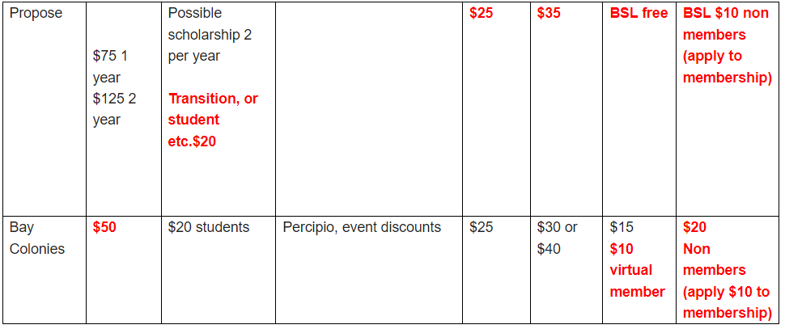

Meeting adjourned: 3:48PM

